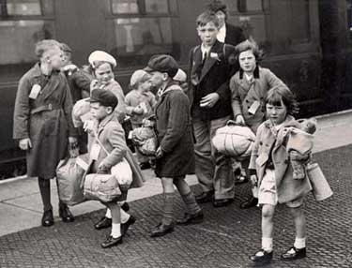
Autumn term 2020 (2nd half)

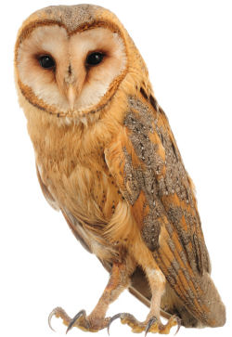
Owl class “A Child at War”

“A Child at War” is obviously a History based project and following our introductory day on Tuesday 3rd November when the children dress as evacuees, they will discover what it was like to be a child during the Second World War. They will be able to consider what it was like to be sent on a long journey away from their homes and families into unknown territory, and will read some of the diary of Anne Frank, written whilst she and her family were in hiding in a secret annexe. They will be encouraged to empathise with her hopes and fears. The children will find out about “make do and mend” and learn about rationing and meals taken by children and their families during the war. They will learn about significant details and dates from the Second World War, and will describe how this period of history has impacted positively or negatively on modern day society. They will make connections and draw contrasts in order to improve their historical perspective. The theme of evacuation will continue in French as we follow a story “Le depart.”

In English, our focus will be on letter writing when the children will have the opportunity to write letters home during evacuation, diary writing linking to Anne Frank and persuasive writing which will take account of War time posters. We will also look at narrative dialogue and speeches - listening to some famous war time speeches and evaluating them – to consider the effect they had on the people who heard them. In class and in guided reading sessions, books and texts that link to World War 2 and evacuation will be read and listened to, eg: an abridged version of “Carries War” by Nina Bawden (our author this half term) and “Goodnight Mister Tom” by Michelle Magorian. At the end of the term, we will watch the film “Goodnight Mister Tom” allowing those who have read it, to compare novel and film. As it is a PG rated film, I will need you to sign the permission slip attached to say that you are happy for your child to watch this.

We will continue to work on spellings, although initially no spelling list will be sent home, as I would like each child to work on individual spellings in order to personalise their learning. The children were excited last half term to dive in to lots of new books which arrived in class, and so I would like to maintain their enthusiasm for reading. Please encourage your child to talk about the books they are reading and to share some reading time each week with them.

Our Mathematics will continue to develop work with the four operations in calculations, in particular, multiplication and division. We will then begin a large block of work on Fractions. This will include using equivalent fractions, adding and subtracting fractions and so on. It is extremely important that the children practise their times tables each week. We will continue to do our times table grids each Friday, and the ability to answer questions quickly and efficiently is key.

The children will use Computing skills to research information about the Second World War using various search technologies, and will also use various presentation software to help them to share information with others.

In D and T, children will be able to build structures linked to our topic. They will learn about different UK locations as they discover more about the evacuation of children during the Second World War, and also about various cities and ports of the UK which were bombed during the Blitz.

The children will listen to wartime songs and music, some of which have become synonymous with the Second World War. They will compose their own songs, perhaps to welcome back soldiers from the war, and will also identify how sounds can be combined and used expressively to create effects.

There will be plenty of opportunity during this topic to empathise with children during the war, whether they be in the UK or elsewhere. There will be many emotive or controversial issues to discuss, and both sides of an argument will need to be considered before personal views or opinions can be formed. Children will consider some of the different beliefs and values in society, demonstrating respect and tolerance towards people who are different to themselves.

PE will still take place on Tuesday and Thursday, but we will need to be flexible in the form this takes, as the weather is likely to become wetter, and it may not always be possible to go outside.

Innovate week during the week of 7th December will give the children the opportunity to celebrate the end of the war! It should be great fun and a super way to end the term!

Owl class film: “Goodnight Mister Tom” (wb 14/12/20)

I give permission for my child ……………………………………………………. to watch the PG rated film “Goodnight Mister

Tom” at the end of term.

Signed …………………………………………………………………..

