“A Child’s War” Homework Grid (Autumn 2) 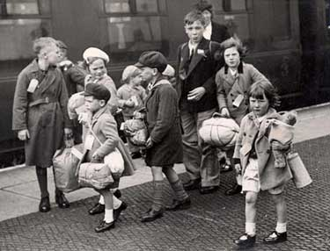
Choose a minimum of 2 activities for this half term. (You must choose at least one activity from each row.) Remember that I expect the homework to be well presented, and it is good to challenge yourself.
The deadlines for homework are: 1) Friday 20th November and 2) Monday 7th December.
Speak to older friends or family about their wartime or post-war experiences. Write down or record their responses. | Keep a diary for a couple of weeks, and record things that are happening in your life. | Our local area was used by the Air Force during the war. Tangmere and Westhampnett/Goodwood were important airfields! Find out about this, and present your information in an interesting way. | Food shortages were common during the war. Find out about wartime rationing and create a poster to encourage people to become more self-sufficient.
Make a scrapbook of Second World War images and write captions for each one. Consider how the people in the photographs may be feeling. | Find some wartime recipes and make a typical meal using foods that would have been rationed at the time. Take photos and record the comments from your family. | Imagine a child has been evacuated to your home. How would you make them feel welcome? Put together a welcome pack! Where would you like to show them or take them to locally? | Make do and mend!  Can you revamp some of your old clothes to make new clothes? Maybe you could ‘upcycle’ some unwanted household items and make them useful in a whole new way! Bring them into school to show us and share your ideas!

