

Jobs

There is plenty of time to decide what we might like to do when we grow up. Even when people do decide, they sometimes change their minds! It can be helpful to think about it though! Use the questions below to help you do this.

What do you enjoy?

What don’t you enjoy?



What are you good at?





Jobs you might like to do:

Jobs you would not like to do:

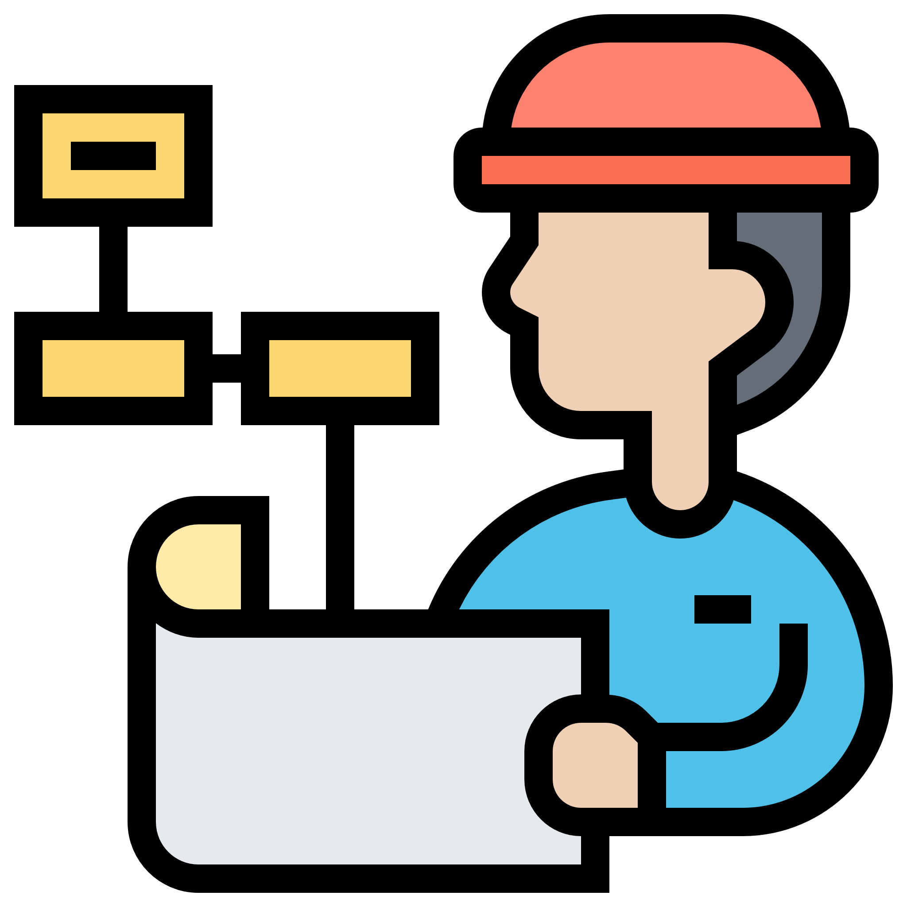

Do you have a dream job at the moment?