Fox Class Autumn 2 2020
Burps, Bottoms and Bile
Please select 2 of the following tasks to complete for homework.
The first piece must be in school by Friday 27th November, the second piece by Friday 11th December. Please remember to think about the presentation of your work. Remember it is important to challenge yourself.
Be a food scientist. Find out which foods are super foods. Why are they good to eat? Write up your findings.
Find out how to boost your immune system. Make a poster to encourage people to look after themselves.
Investigate the teeth of 2 different animals. Present your findings.
Drop grubby copper plated coins into a range of fizzy drinks and leave them overnight to see what happens. Which brand has the most powerful cleaning properties? Write up your findings.
Investigate the amount of sugar in different sweets. Can you present your data as a table? Graph?
Some people sneeze because they are allergic to certain substances. Can you find out about different allergies?
Try a new food or drink that you have never tasted before. Can you write some food tasting notes?
Keep a food diary for a week. Look carefully and comment on the nutritional value of your diet. How much sugar have you had?
Create a poster to teach people about the Human skeleton
How many muscles do we have? How do they work? Can you present your findings
How do you know if something is living? What are the seven Life Processes
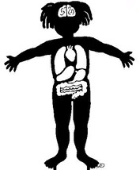
We have recently introduced Google classroom with the children (separate letter regarding this to follow). To get the children used to using this new platform, we have also set a piece of English homework on their Google classroom account. The children have all been shown how to log in to their accounts and how to access the homework. This is due in by Friday 13th November. There is no need for this homework to be printed as it will be saved and submitted automatically once the children access and edit the document.

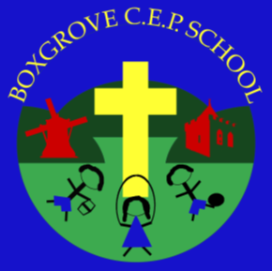
B O X G R O V E
C. OF E. PRIMARY SCHOOL

Working Together For Our Children’s Future
Boxgrove C. of E. Primary School
The Street, Boxgrove,
Chichester, West Sussex PO18 0EE
T 01243 773309 F 01243 785640
office@boxgrove.w-sussex.sch.uk
www.boxgrove.w-sussex.sch.uk

Headteacher:
Mrs Jacqui Dommett

Friday 20th November

Dear Parents and Carers,
Welcome to the Autumn 2 half term!
Firstly, we would like to say a big thank you to those of you who made a monetary contribution to our topic last half term. Thanks to your generous donations, we were able to carry out lots of exciting activities, including bread making, and bread and fruit tasting. We hope your children came home and told you all about these different lessons!
For our topic this half term, we are hoping to carry out some memorable experiences and to give the children the opportunity to partake in various fun activities, including even more exciting food activities! In order to do this, and to make the experience as memorable and enjoyable as possible, we are asking for a voluntary contribution of £1. Please could the monies be brought in by Friday 27th November.
Thank you for your continued support,
Mrs Pearson and Mrs Whittle.
…………………………………………………………………………………………………………………………
Fox Class Topic Contribution
I enclose a contribution of £1.
Child’s name:……………………….
Fox Class

