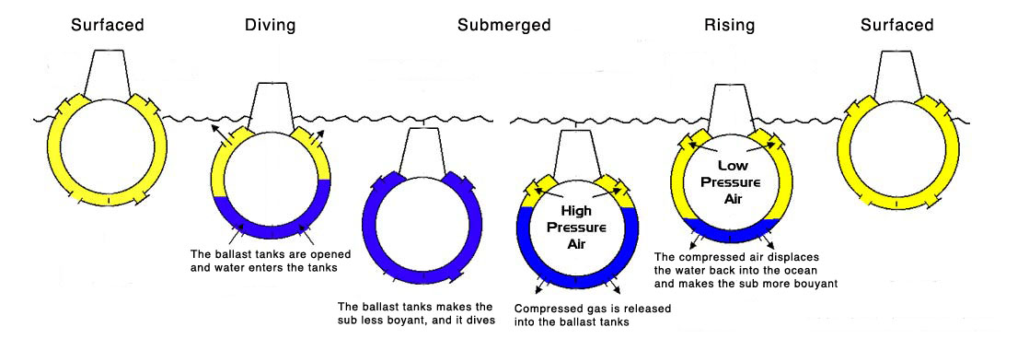

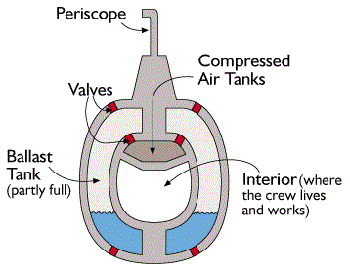
When the submarine is at the surface, its ballast tanks are filled with air, thus making its density less than that of the surrounding water. In order to submerge, the ballast tanks are filled with water, making the overall density of the ship higher than the surrounding water

1620
The first successful submarine was built in1620 by Cornelius Jacobszoon Drebbel, a Dutchman in the service of James I of England, which may have been based on Bourne's design. It was propelled by oars and is thought to have incorporated floats with tubes to allow air down to the rowers.

